Vrixzandro Cunamay Eliponga System Administration and Maintenance

BT1203 07 Quiz 1 - ARG

**For item #1**

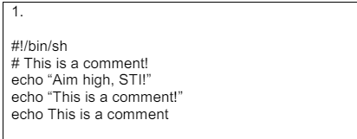

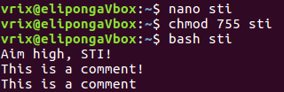

**For item #2**

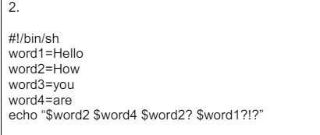

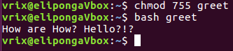

**For item #3**

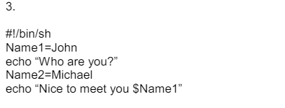

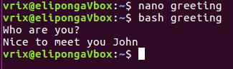

**For item #4**

